Vision and Objectives Statement for the
Civil Parish of Dinton, Wiltshire

“Objectives to sustainably maintain a naturally beautiful rural parish of viable settlements containing a balanced range of quality built accommodation, services and employment opportunities; in a way that preserves or improves the overall quality of life and community spirit of current and future parishioners.”

Contents

Introduction Page 3

Vision Page 3

Local Geography Page 3

Local Environment Page 3

Objective 1 Acceptable Levels of Growth Page 4

Objective 2 Acceptable Access Page 4

Objective 3 Acceptable Scale Page 5

Objective 4 Acceptable Design Page 5

Objective 5 Minimal Environmental Impact Page 6

Objective 6 Sustainability Page 6

Objective 7 Fulfilment of local needs Page 6

Objective 8 Loss of Amenity Page 7

Annex A Map of Settlement boundaries. Page 8

Annex B Analysis of Housing Stock and Needs To Follow

Vision and Objectives Statement for the Civil Parish of Dinton, Wiltshire

Introduction
This statement covers the vision and objectives on which Dinton Parish Council (Dinton PC) has agreed with respect to development and local planning matters within the Parish. It expresses the objectives that the Parish Council expect developers and Wiltshire Council as the Local Planning Authority (LPA) to comply with when Planning applications affecting Dinton PC are drafted or considered. The Parish Council welcomes formal discourse and consultation with developers, large and small, prior to and during the planning application process. Applicants are particularly welcome to address the Parish Council at the advertised meeting during which the application will be discussed.

The Vision
“To sustainably maintain a naturally beautiful rural parish of viable settlements containing a balanced range of quality built accommodation, services and employment opportunities, in a way that preserves or improves the overall quality of life and community spirit of current and future parishioners.”

Local Geography
Dinton Civil Parish (Dinton CP)lies within the Unitary Authority of Wiltshire and the Wilton Community Area as defined by the Wiltshire Core strategy. The Parish is in the UK Parliamentary constituency of South West Wiltshire.Dinton CP is joined to the Parishes of Wylye (containing the A303) in the North and Fovant (containing the A30) in the South by a C class road. The main communication route through the Parish is the B3089 joining the Parish of Teffont in the West to the Parish of Barford St Martin in the East and from there on to the town of Wilton and City of Salisbury. The Exeter to Waterloo railway line runs through the village, although the station is no longer in use.

The parish lies in the Nadder Valley, having the river as its southern boundary. Outside the settled areas it is made up of largely pastoral land with some interspersed agriculture and woodland. Dinton CP comprises the medium sized village of Dinton, the hamlet of Baverstock to the Eastand the small outlying settlement of Marshwood to the North. An ancient ditch boundary running within Grovely Wood forms much of the Northern boundary to the parish.

Local Environment
The whole of the Parish falls within the Cranborne Chase and West Wiltshire Downs Area of Outstanding Natural Beauty (CCWWDAONB shortened to AONB). There are a number of sites and buildings within the Parish of historic or scientific interest, it is therefore particularly important to maintain the built environment and historic setting in some areas of the Parish. The National Trust is a major landowner owning about 150 acres (60 hectares) in the Parish. Dinton CP has a number of business areas that are suitable for light industry and storage centred on redundant Defence infrastructure and the site of a disused brickworks.
Objectives

1. To ensureacceptable levels of growthin Dinton CP proportionate to the need, size, character and environment of the Parish.(Outline development for 30 houses on Westfields Business Park already agreed within Policy H10 preserved from South Wilts Local Plan 2003.
a. In order to preserve the rural environment, no development larger than two new or replacement dwellings will be supported outside of the built up area of the settlement of Dinton.
b. Extension of the built up area to include proposed developments for affordable housing will be supported if:-
i) The development is adjacent to the existing built up area.
ii) The development is for affordable housing only.
iii) A clear affordable housing need from parishioners in Dinton PC for at least 80% of the proposed development has been identified.
c. In order that a cohesive community is maintained,applications for new dwellingswill not be supported that see the total number of dwellings in the Parish rising by more than 15% in any rolling 10 year period.
d. In order to maintain local employment and community service provision, an application that reduces the net employment opportunities or community services available within the Parish will not be supported.
e. In order that housing provision meets housing needs, development that significantly reduces the balance between locally needed, but under-provisioned housing types and locally over provisioned housing will not be supported. Factors for consideration will include
i) Building type, eg Bungalow, House or Flat
ii) No of bedrooms.

2. To ensure acceptable accessis provided for all developments in Dinton CP.
a. Due to the lack of good public transport links and associated reliance on private transport, developments(other than for sheltered accommodation) will not be supportedunless a minimum of two parking spaces per dwelling is provided. Developments for multiple dwellings will not be supported unless additional parking spaces are provided for visitors at a ratio of one additional parking space for every three dwellings.
b. To avoid vehicles reversing from properties on to the highway, developments will not be supported unless adequate space is provided for the turning of light goods delivery vehicles within the site.
d. To ensure safe pedestrian access, developments of 5 dwellings or more will not be supported unless pavement footpaths with drop kerbs at road crossing points are provided. New footpaths must as far as is possible link to the existing network of pavement footpaths.
e. To ensure inclusive access, steps leading to any development should be minimal. Developments that use steps to access bungalows, ground floor flats or sheltered accommodation will therefore not be supported.
f. To ensure the amenity of residents, DPC will make it conditional of any support that if a new site access is to be provided or improved, that such work is carried out as early in the development as possible and before any groundwork has begun.
g. Dinton PC will seek to safeguard local schoolchildren from motor vehicles particular those using the B3089 by seeking the removal of on-road parking outside the school to an alternative location, that sufficient safe crossing points are provided at appropriate locationson the main walking routes to the school and if necessary the extending of traffic calming measures.. Developments that significantly increase the volume of traffic past or adjacent to the school will not be supported unless these objectives are as far as is practicable addressed.
h. Dinton PC recognises the lack of paved footpaths in many parts of the Parish and will support so far as is practicable the provision of footpaths linkingcommunity assets such as Halls schools, pre-schools, churches, shops and public houses.

3. To ensure an acceptable Scale of Developmentwithin Dinton CP.
a. Retaining open space within and between developments is essential in maintaining a village or rural setting. DPC will therefore only support developments of an appropriate density which matches the surrounding area.
b. In order to maintain the historic character of the settlements and preserve historic space, no new development constituting “infill” will be supported adjacent to and between two propertiesthat are more than 100 years in age at the time of application.
c. In order to retain space in front of buildings no development, other than the addition of appropriately scaled porches in front of existing building lines will be supported.
d. In order to maintain an appropriate scaled skyline or roof-scape Dinton PC will not support a development where the proposed ridge height exceeds the ridge height of allthe adjacent properties.

4. To ensure acceptable designquality and purpose within Dinton CP.
a. DintonPC will only support developments where design aspects are of sufficient quality and in keeping with the immediate local area.
b. DintonPC will not support a development that has no clear use.
c. Dinton PC will not support a development that includes free standing commercial signage which dominates the developed area.
d. Traditional building materials are preferred especially in the older built areas of the settlements. Modern or industrial design aspects such as extensive glazing, or extensive exposed concrete or metal structure will only be supported where the public visual impact is minimal.

5. To ensure minimal environmental impact within Dinton CP.
a. Energy efficient developments, both in terms of construction and use are strongly encouraged.
b. The loss of any habitat for native species should be minimised. Developments requiring excessive removal of habitat, including trees and hedges without replacement or relocation will not be supported.
c. The diversion or alteration of any watercourse can have serious implications to residents, Dinton PC will consider seriously any such alteration and will not support a development where both up and down stream affects have not been considered.
d. The local foul water and sewage disposal network is at capacity. Dinton PC will not support any significant developments that do not allow for a sufficient increase in the sewerage capacity.
e. In line with the CCWWDAONB “Dark skies” policy, Dinton PC wishes to prevent excessive light pollution emanating from all developments. To this end there is a preference for Dormer style windows over Velux style windows within Dinton CP. Dinton PC will only support developments where upward facing windows in lit rooms are shielded or screened during the hours of darkness.
f. DintonPC recognises the environmental value of trees and hedges within the Parish and encourages the planting of more within new developments.

6. To express preference for sustainable development in Dinton CP.
a. There is a preference for the use of sustainable materials that have been as far as is practicable locally sourced.
b. There is a preference that as far as is practical local tradespeople are employed to carry out the work on all developments.

7. To ensure the fulfilment of local needsin Dinton CP.
a. There is a need to provide a balance of housing stock for the community that fulfils the community’s needs in terms of dwelling type, size, price and tenure. Dinton PC will not support a development that removes an under-represented building type and replaces it with an over-represented building type.
b. DintonPC wishes to see sufficient affordable or social housing provided to meet the communities need. Dinton PC will not support a development for affordable social housing that isn’t predominantly reserved for the benefit of those with close ties with Dinton CP.
c. Dinton Village has been identified by Wiltshire Council as a settlement that will support further development when trying to satisfy the Counties housing needs. Such an expanding community requires the retention of all community services. Dinton PC will therefore not support any development which removes without replacement any service to the community.
d. Local employment opportunities are vital to a healthy and sustainable community. Dinton PC will not support any development which changes the use of a building or piece of land from one which supports employment to a use which doesn’t. Additionally Dinton PC will not support any development where the number of employment opportunities are significantly reduced.
8. To ensure minimal loss of amenityin Dinton CP.
a. Although an individual doesn’t possess a right to a view, Dinton PC will not support any development which removes a collective view that is valued by the community.
b. DintonPC will not support any development which results in significant over-shadowing of another dwelling.
c. DintonPC will not support industrial processes that produce excessive noise or antisocial smells affecting neighbouring dwellings or businesses.
d. DintonPC will not support industrial operation outside of the hours of 0700-1900hrs Monday to Friday and 0800-1300 on Saturdays.
d. DintonPC requires that disruption during the development phase is kept to a minimum. Particular consideration should be given to hours of construction and Keeping highway obstructions to a minimum.Dinton PC will make it conditional of any support that any damage made to neighbouring grass verges caused by construction traffic is made good before the development is completed.

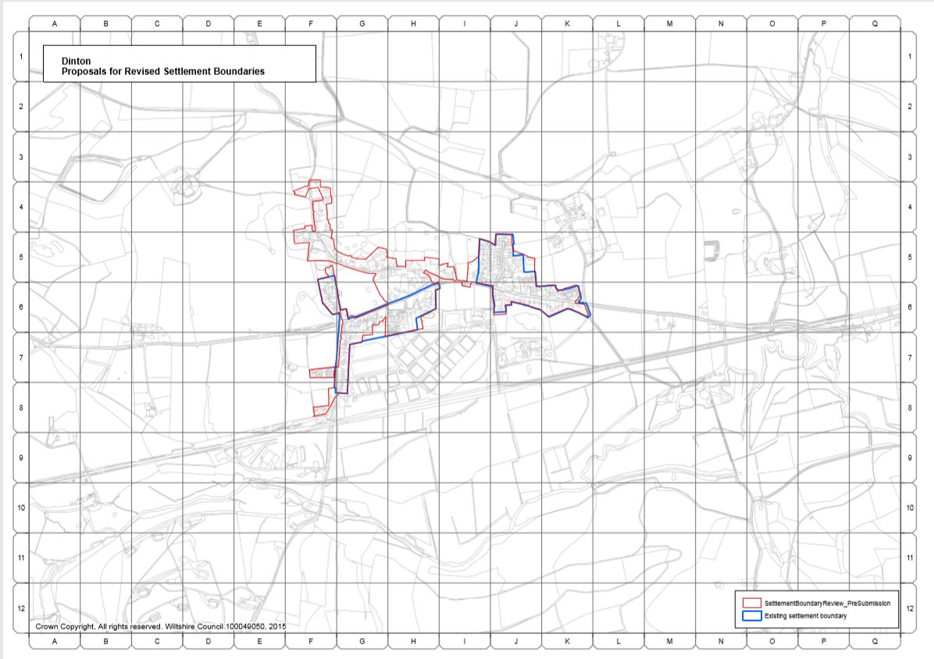
Annex A

Dinton Civil Parish is the official name of the parish, the word civil is used to differentiate from the ecclesiastical parish associated with the churches in Dinton and Baverstock.

