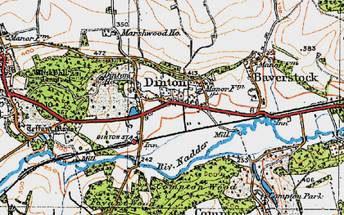

Dinton Parish Council
Cllr Gary Rowitt (Chair)
cllrrowitt@dintonparishcouncil.org

__________________________________________________________________________

Dear Councillor,
You are hereby summoned to attend the next meeting of
Dinton Parish Council
on Monday 21st MARCH 2022 at 7:30pm in the Dinton Village Hall.
Please use a face covering for the safety of all persons attending the meeting.
* Questions or statements from members of the public on any matter concerning the parish, no parishioner may speak for more than 3 minutes.

* Report from Wiltshire Councillor – Cllr B Wayman.

Agenda

29/22 Apologies for absence and to consider whether to approve the reasons given.

30/22 Minutes of last meeting. sign the minutes of the parish council meeting held on

21st February 2022.

31/22 Declaration of interest. .
- Cllrs to declare any Disclosable Pecuniary Interests related to any matters to be considered in this agenda that do not appear in the Cllr’s register of interests.
- In accordance with the Dispensation Procedure, any requests for a grant of dispensation must be submitted prior to this meeting.

32/22 Exclusions of press and public. To agree any items to be dealt with after the public, including the press, have been excluded.

33/22. Should DPC change of meeting day to third to Tuesday each month.

34/22. Planning. Application number PL/2022/01051 Dinton Recreation Ground, play equipment.

All councillors to view before the meeting;

(i) To consider how to respond to any planning applications made after the publication of this

(ii) To receive an update on planning matters previously considered by Dinton PC.
PL/2022/00200 1 Loveacre approved without roof lights.

(iii) Tree applications. To note any tree applications received after the publication of this agenda.

35/22. Finance Year ending 31st March 2022.

To note the balance of the accounts.
Opening balance £11257.39
Total receipts £21058.13
Total payments £11403.37
Balance £21536.75
This includes ring fenced / committed monies totalling £ 15135.85 leaving an available balance of £6330.90
The balance of the bank accounts on 13/02/2022 is £18207.97 which includes uncleared funds of £70.
- To note the current budget / spend.
- To consider ring fenced monies and vire across if required.
- To note payments made since the last meeting.
- To authorise terms of expenditure, as detailed in the schedule of payments.
- IOC:- £35
- Bus shelter cleaning:- £ 30
- Postage:- £2.25
- Jubilee celebrations costs
- Update on Bank signatories. Cllr Southern and Cllr Upton
- Update on Village Hall payments, Cheque now cashed.

36/22 Jubilee update . Cllr McCarthy

1) Gifts, which gift.

2) How many.

3) Cost.

37/22 Emergency plan Update. Cllr Southern

38/22 Parish Councillor vacancy. Co-opt.

39/22 Reports from Parish Councillors.

Cllr Rowitt, Cllr Southern, Cllr Bennie, Cllr McCarthy, Cllr Smith and Cllr Upton.

40/22 Dinton Parish Clerk.

1) DPC to decide whether to employ one of the applying candidates.

2) Chairman proposes Ms M Camillieri as Parish Clerk

3) Update on ex Parish Clerk

.

41/22 Clerks report. Chairman / Ms Camilleri to give report.

42/22 Vote of confidence in Chairman

43/22 Items for next meeting on Tuesday 19th April 2022 at 19.30 hours must be with Cllr Smith by 4th April 2022.

(3)

